









https://smokefreesomerset.org.uk
O1823 356222
smokefree@somerset.gov.uk

Smoke 2O a day?
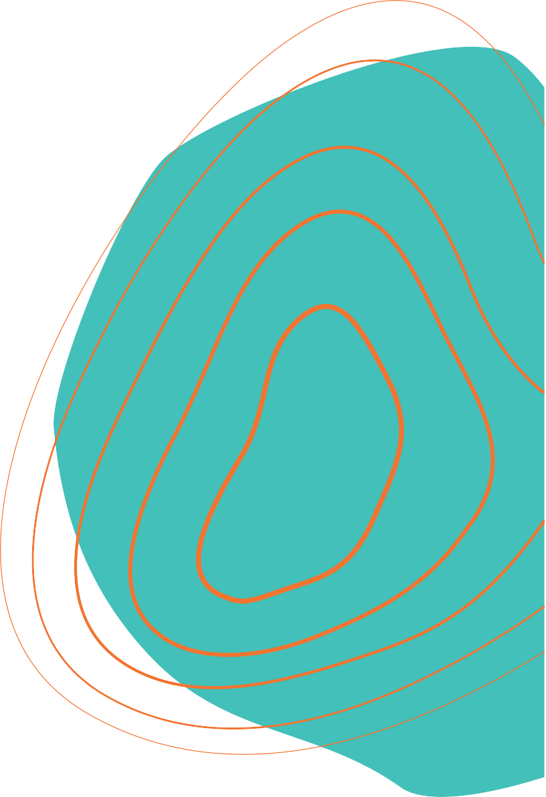

Quit & save up to

£6,OOO

a year

Stop your money going up in smoke!
 Better health More money  More choice

