How smoking harms the body

Heart
Doubles the risk of having a heart attack.

Lungs
It causes 84% of deaths from lung cancer and 83% of deaths from COPD.

Brain
Increases risk of having a stroke by at least 5O%.

Mouth and throat
Increases risk of cancer in lips, tongue, throat, voice box and
gullet (oesophagus).

Circulation  Increase blood and heart rate. |  | Stomach
Circulation  Increase blood and heart rate. | pressure Increases chance of getting  stomach cancer or ulcers.

Fertility (men)
Smoking can cause impotence in men.

Bones
Can cause bones to become weak and brittle, increasing the risk of osteoporosis in women.

Fertility (women)
Smoking can make it harder
to conceive.

Skin
Prematurely ages skin by between 1O and 2O years.

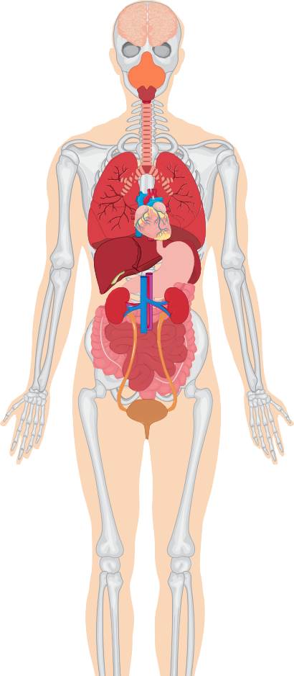
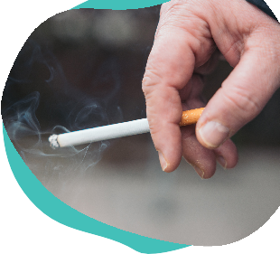
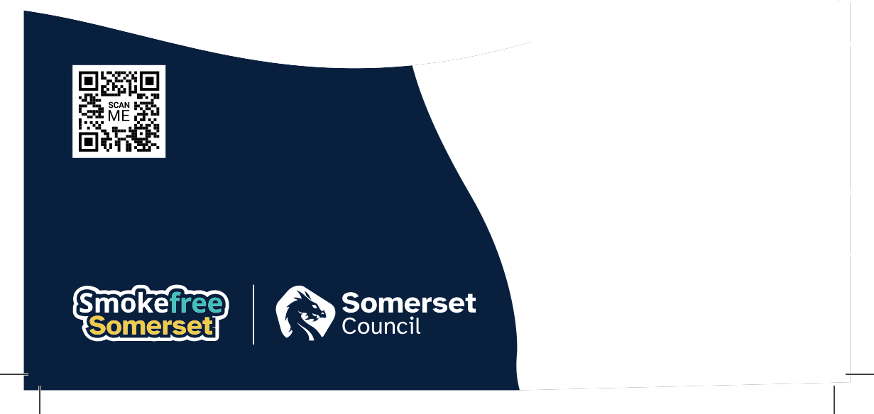

https://smokefreesomerset.org.uk O1823 356222

smokefree@somerset.gov.uk



Smokefree Somerset provides support for smokers to quit through its GoSmokefree, Smokefree Families and Light Touch pathways. A 12 week programme for anyone aged 12+ in Somerset, combining behavioural support with nicotine replacement therapies, vapes, or prescription medicines
(if suitable). There are options to join a community-based support group, face-to-face sessions, drop-ins, and phone or online support.

The service provides a variety of treatment options, all encouraging and supporting habit and behaviour changes, with licensed stop-smoking medications and vapes available to reduce nicotine withdrawal.

Health Benefits of Stopping Smoking
- Improved blood pressure.
- Taste and smell return.
- Skin and teeth improve.
- Lower risk of cancer, heart attack, coronary heart disease and lung disease.
- Reduced risk of circulatory problems such as peripheral vascular.

- Stroke risk halves within 2 years and is similar to a non-smoker’s within 5 years.
- Fertility & pregnancy: fertility improves and the chance of a healthy pregnancy and baby increases.
- No secondhand smoke for family, friends and colleagues.
- Children face lower risks of bronchitis, pneumonia, asthma attacks, meningitis and ear infections.

O1823 356222
smokefree@somerset.gov.uk https://smokefreesomerset.org.uk

