





https://smokefreesomerset.org.uk
O1823 356222
smokefree@somerset.gov.uk



Smoke 2O a day?
Quit & save up to

£6,OOO

a year

Stop your money going up in smoke!

 Better health  More money More choice



Smokefree Somerset provides support for smokers to quit through its GoSmokefree, Smokefree Families and Light Touch pathways. A 12 week programme for anyone aged 12+ in Somerset, combining behavioural support with nicotine replacement therapies, vapes, or prescription medicines
(if suitable). There are options to join a community-based support group, face-to-face sessions, drop-ins, and phone or online support.

The service provides a variety of treatment options, all encouraging and supporting habit and behaviour changes, with licensed stop-smoking medications and vapes available to reduce nicotine withdrawal.

Health Benefits of Stopping Smoking
- Improved blood pressure.
- Taste and smell return.
- Skin and teeth improve.
- Lower risk of cancer, heart attack, coronary heart disease and lung disease.
- Reduced risk of circulatory problems such as peripheral vascular.
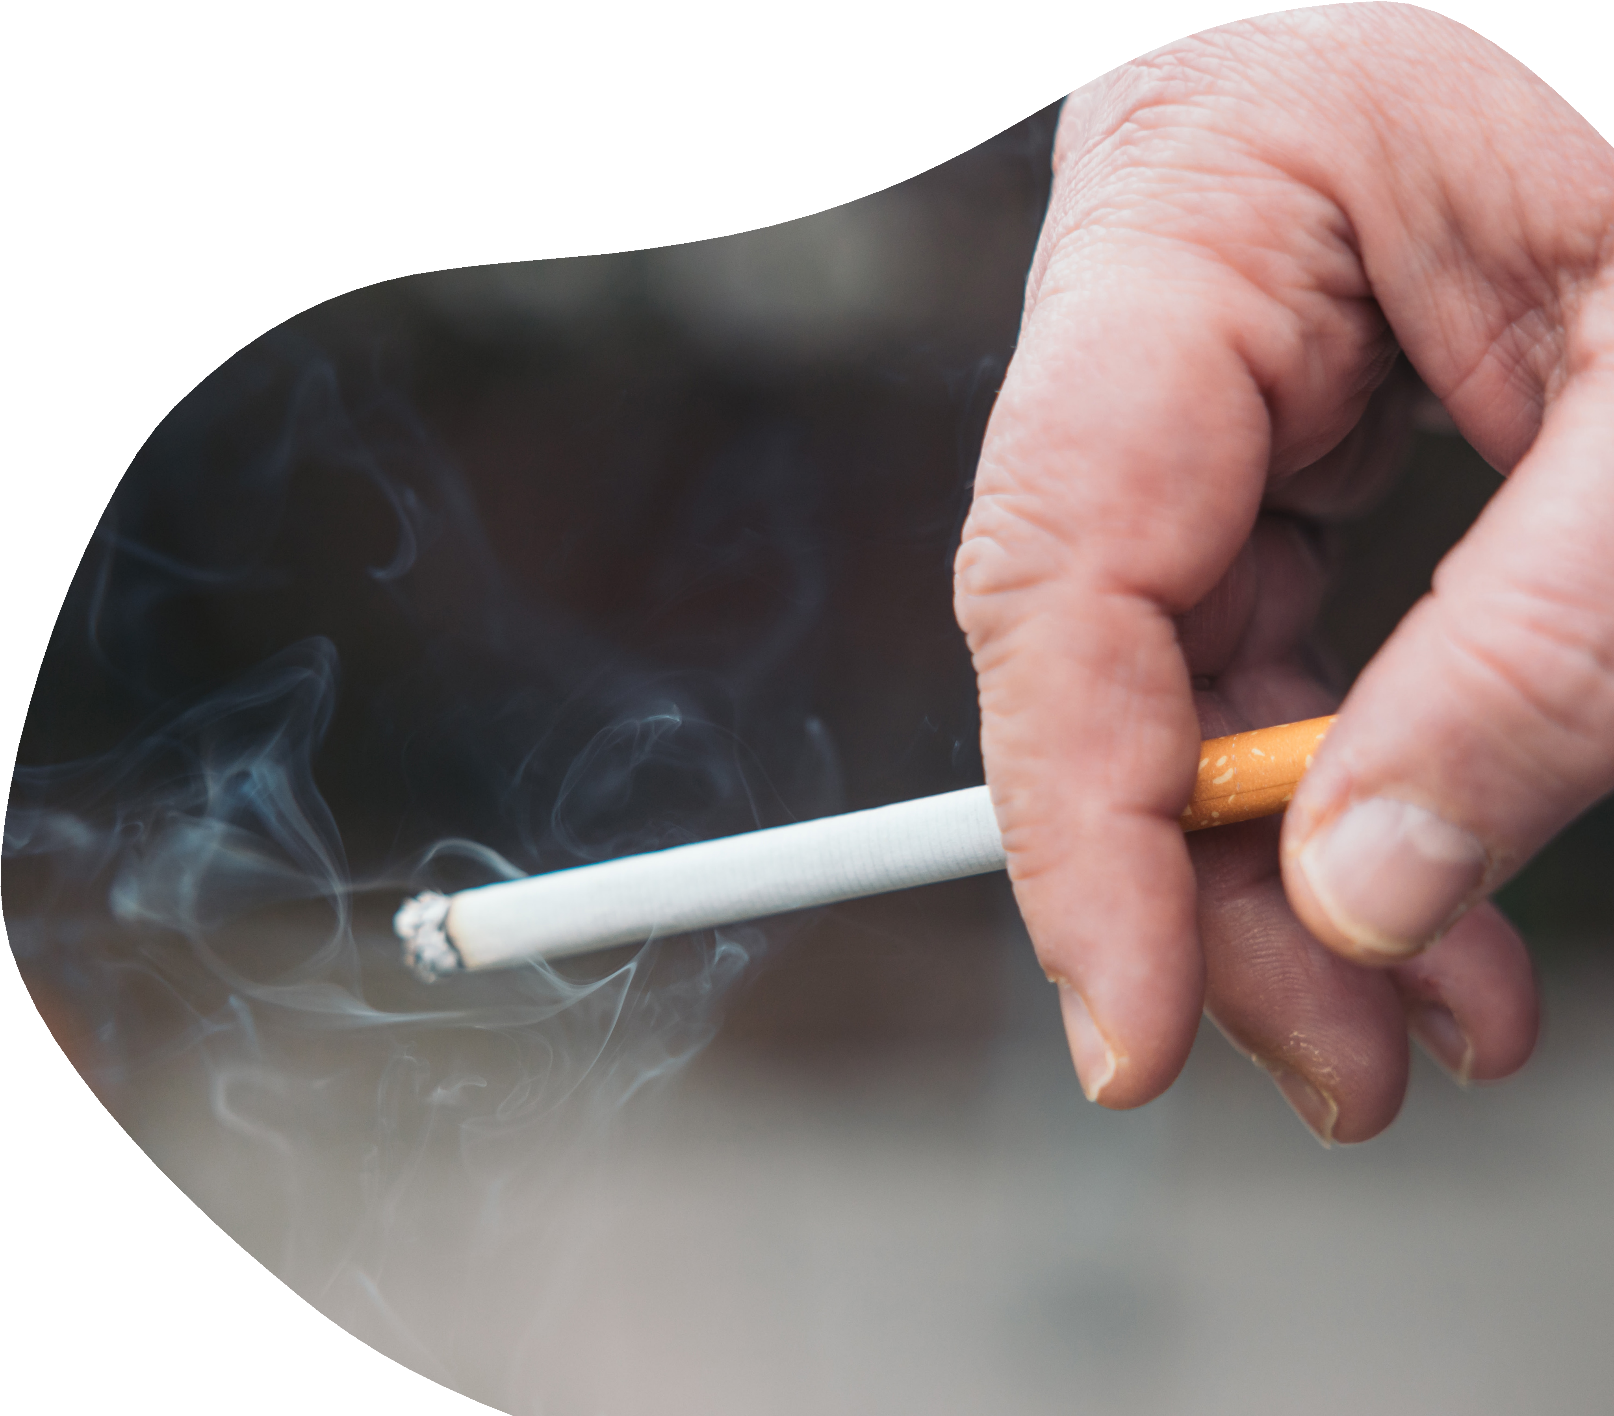
- Stroke risk halves within 2 years and is similar to a non-smoker’s within 5 years.
- Fertility & pregnancy: fertility improves and the chance of a healthy pregnancy and baby increases.
- No secondhand smoke for family, friends and colleagues.
- Children face lower risks of bronchitis, pneumonia, asthma attacks, meningitis and ear infections.

O1823 356222
smokefree@somerset.gov.uk https://smokefreesomerset.org.uk

