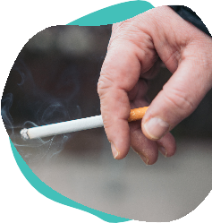
Smoke 2 O a day?
Quit & save up to

£6,OOO

a year
Stop your money going up in smoke

Better health More money More choice




https://smokefreesomerset.org.uk
O1823 356222
smokefree@somerset.gov.uk

